EXERCISE NO:1

DATE:11/10/2020

AIM:

TO WRITE THE PYTHON PROGRAM TO PRINT THE CALENDER OF THE GIVEN MONTH AND YEAR.

PROGRAM:

import calendar

year=int(input())

month=int(input())

if(year<10000 and year >999 and month<13 and month>0):

print(calendar.month(year,month))

else:

print('Invalid Input')

LINK:

<http://103.53.53.18/mod/vpl/forms/edit.php?id=229&userid=1678>

OUTPUT:

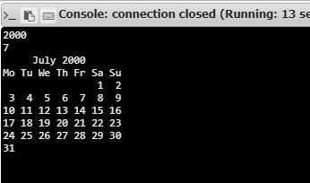

RESULT:

THUS, THE CALENDER OF THE GIVEN MONTH AND YEAR IS PRINTED